Lab2

Configure IIS in Windows Instance – for beginners

While logged into AWS Console, we can able to see “EC2” service.

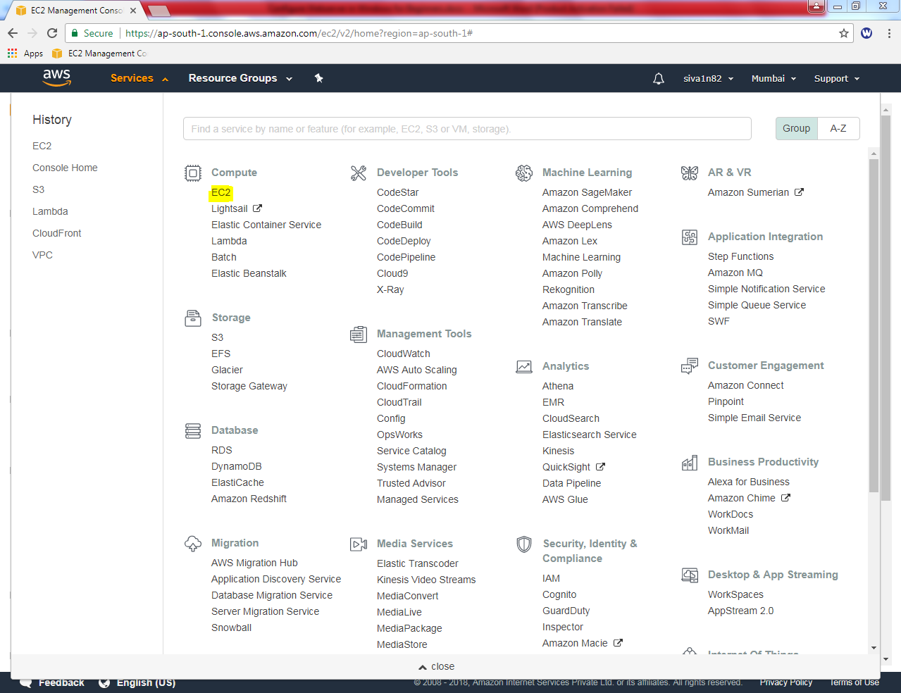

Click “EC2” service.

Then click “Launch Instance”.

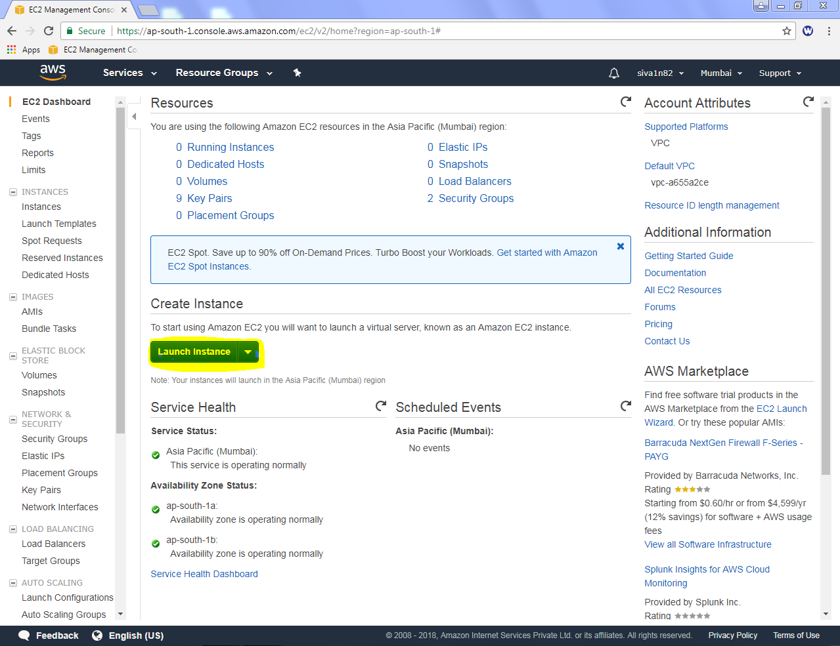

Select “Microsoft Windows Server 2016 base” AMI.

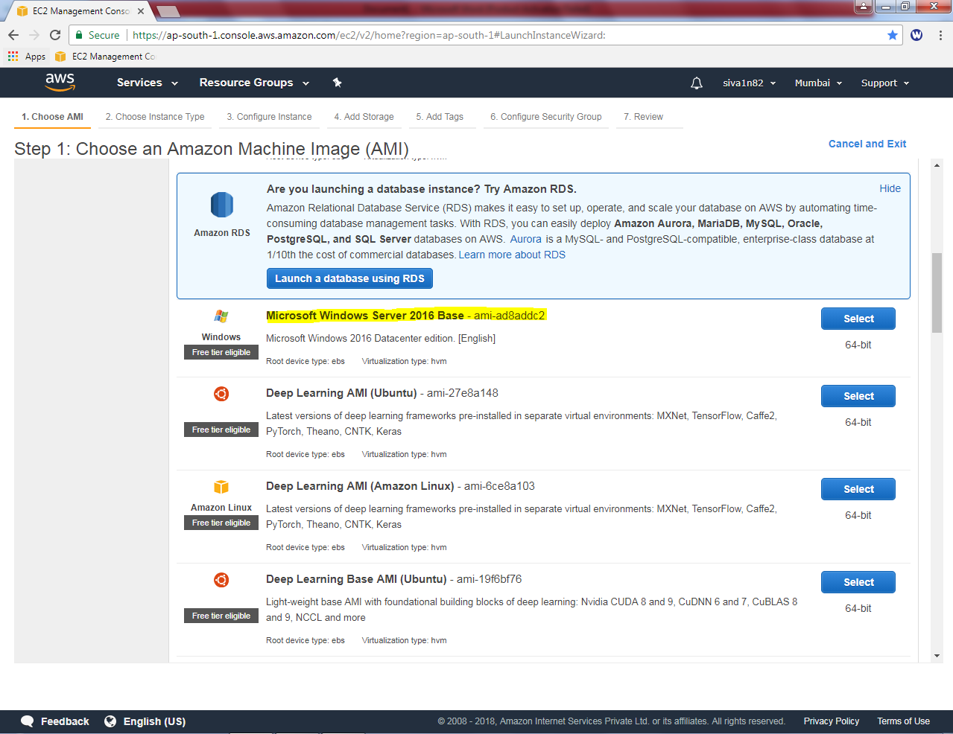

Then ensure “General Purpose” t2.micro is selected.

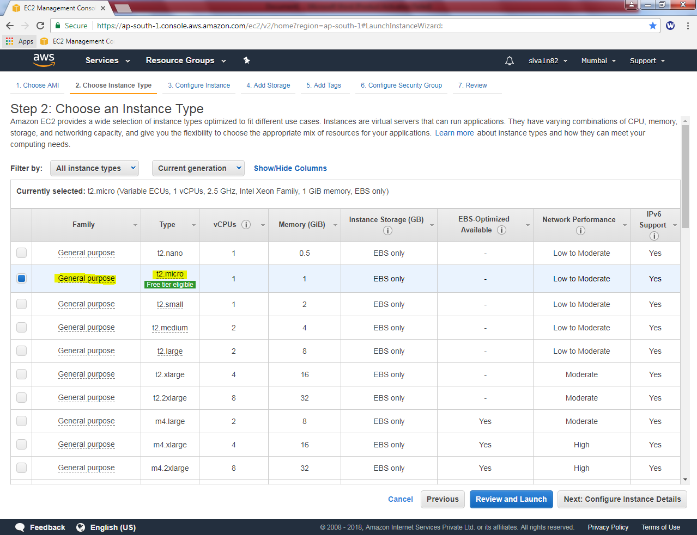

Click “Next”.

Leave the default settings and click “Next”.

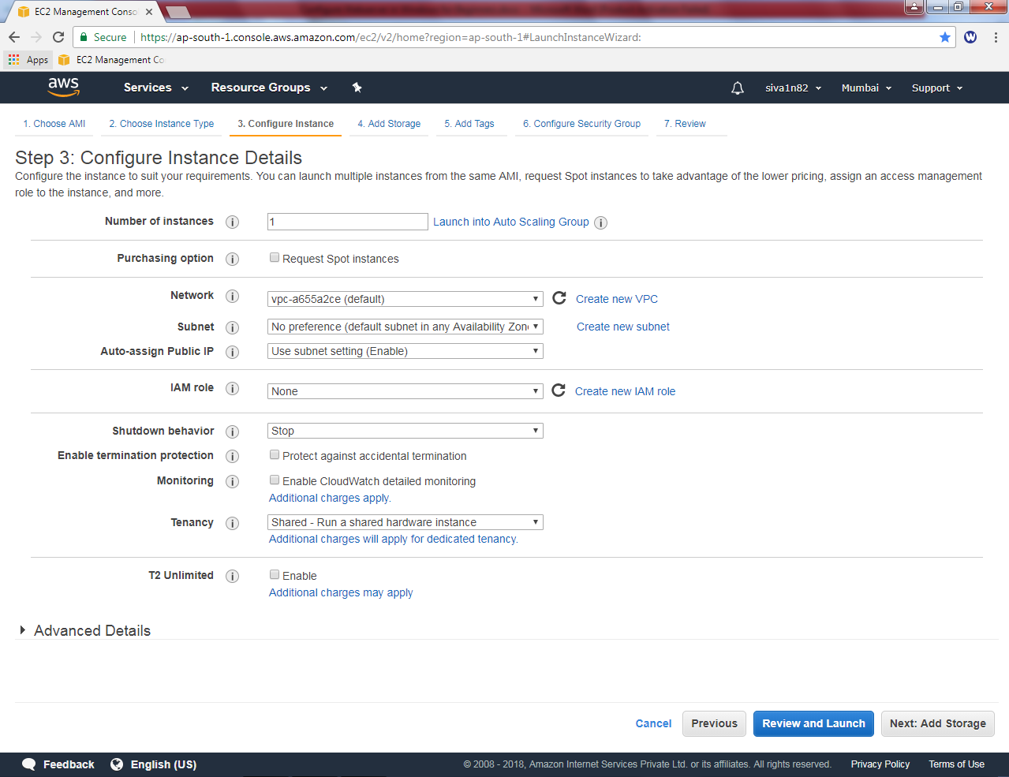

Leave the default settings and click “Next”.

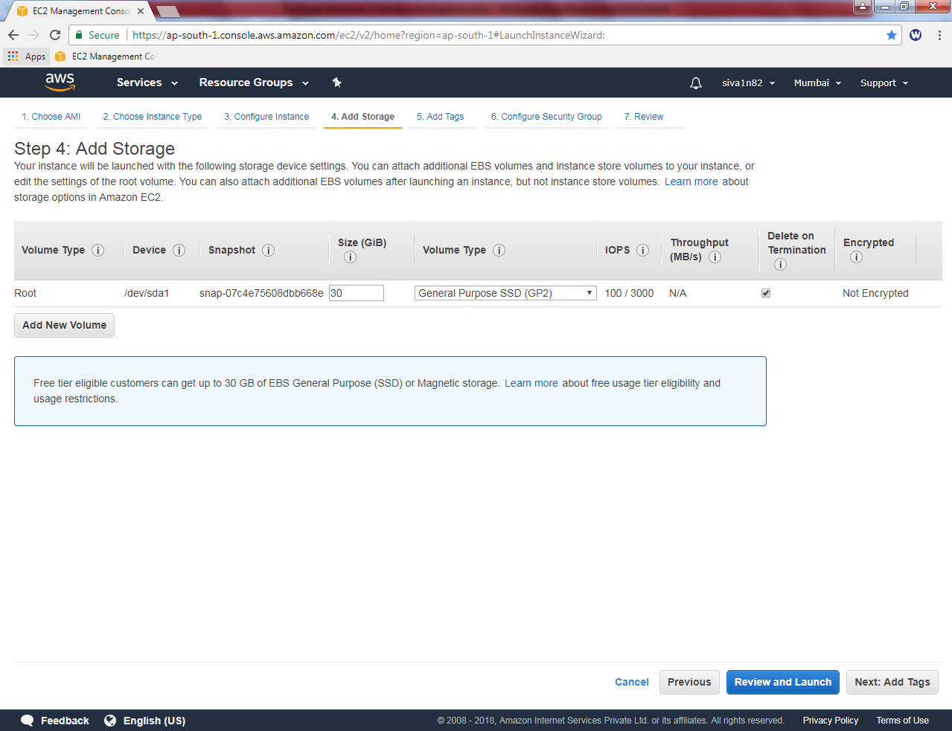

In Add tags, type Key as “Name:” (Optional) and Value as “Windows 2016 Instance” (Optional).

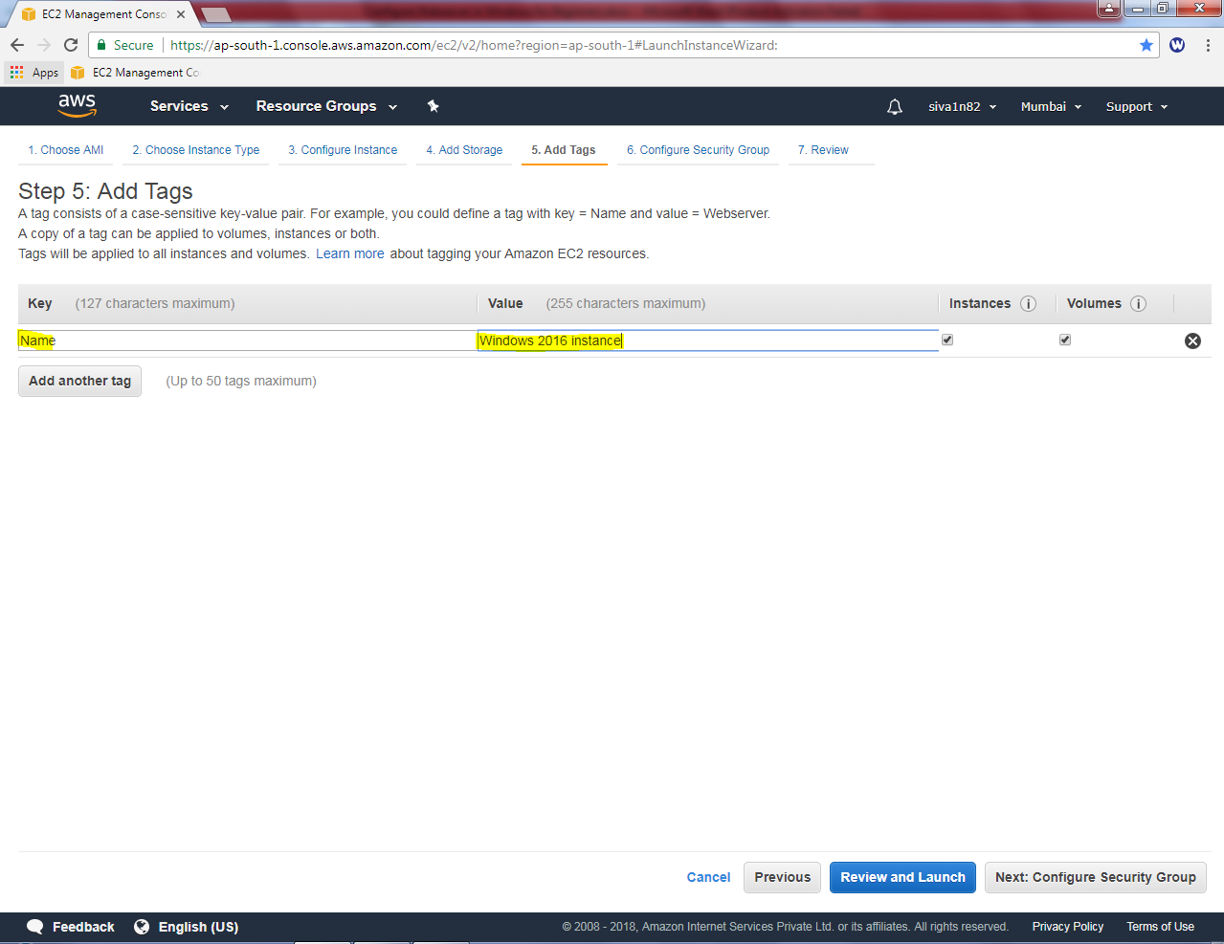

In Security group, create a new security group and type security group name as “Evening_Sec_Group” and description as “Evening_Sec_Group”. You can able to view that RDP port is permitted in Security group for manage the instance remotely.

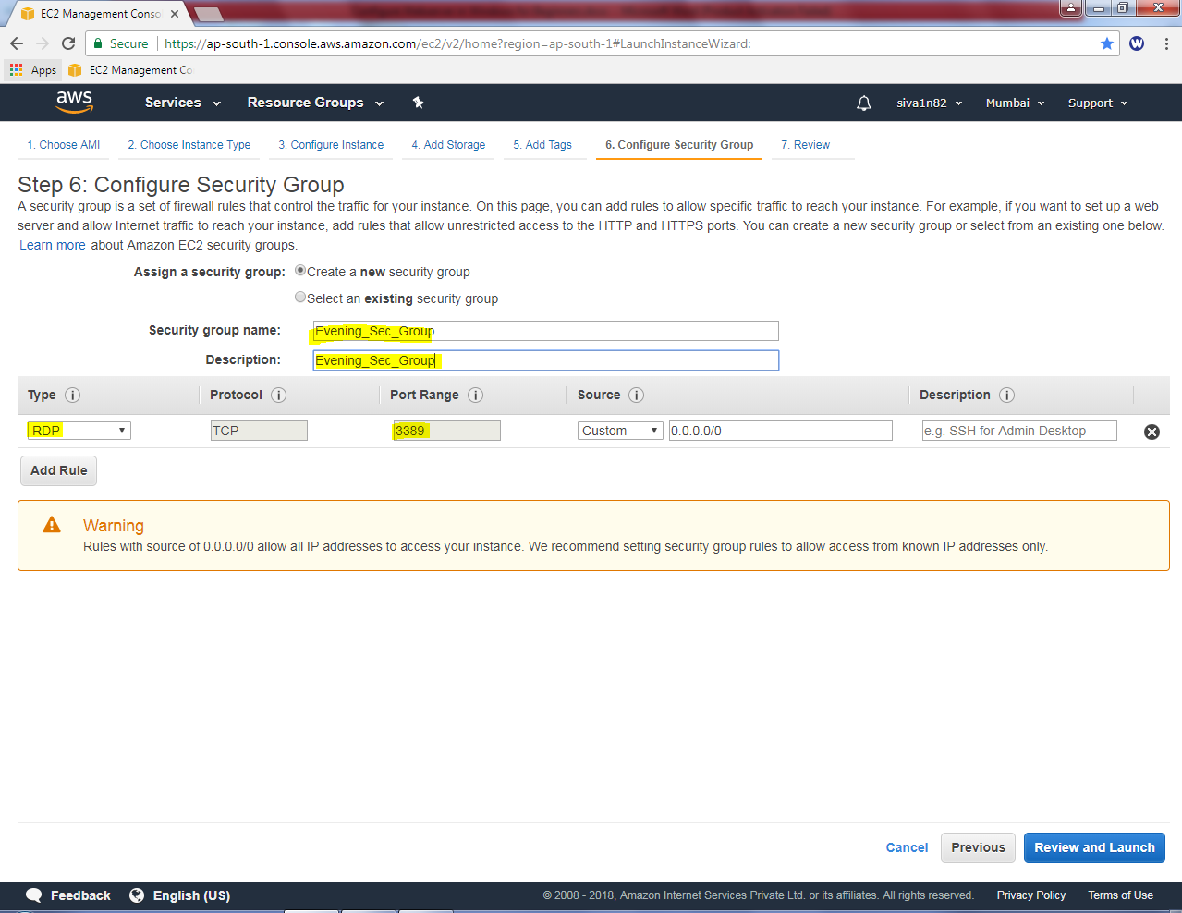

Click “Review and launch”.

Leave default settings and Click “Launch”.

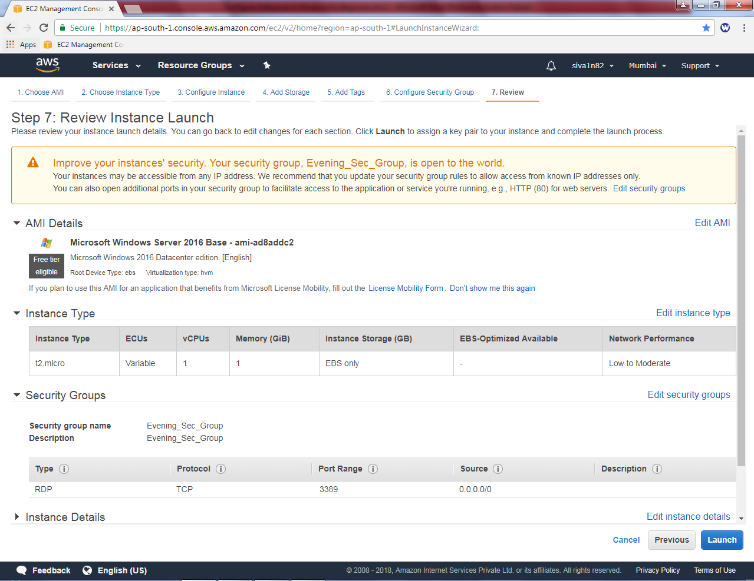

While click “Launch” button, it prompts to select Key pair or create a new key pair option.

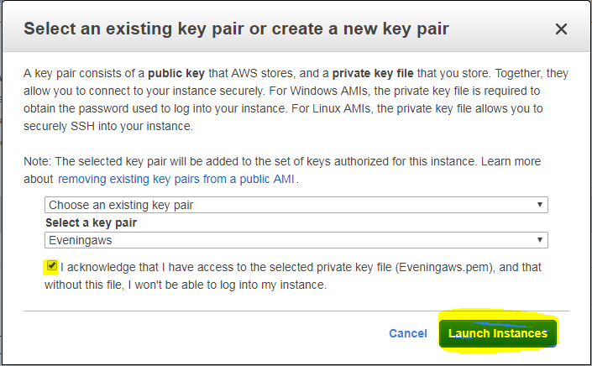

Select the choose an existing key pair if you have already downloaded *.pem file. Otherwise click create a new key pair. We have already key with us, hence I have selected choose an existing key pair option. And select the “Eveningaws” key from drop down box. Then click “I acknowledge”.

Click “launch instance”.

Now you have created an instance and launched successfully. Click the highlighted area or view instance to view the windows 2016 server instance.

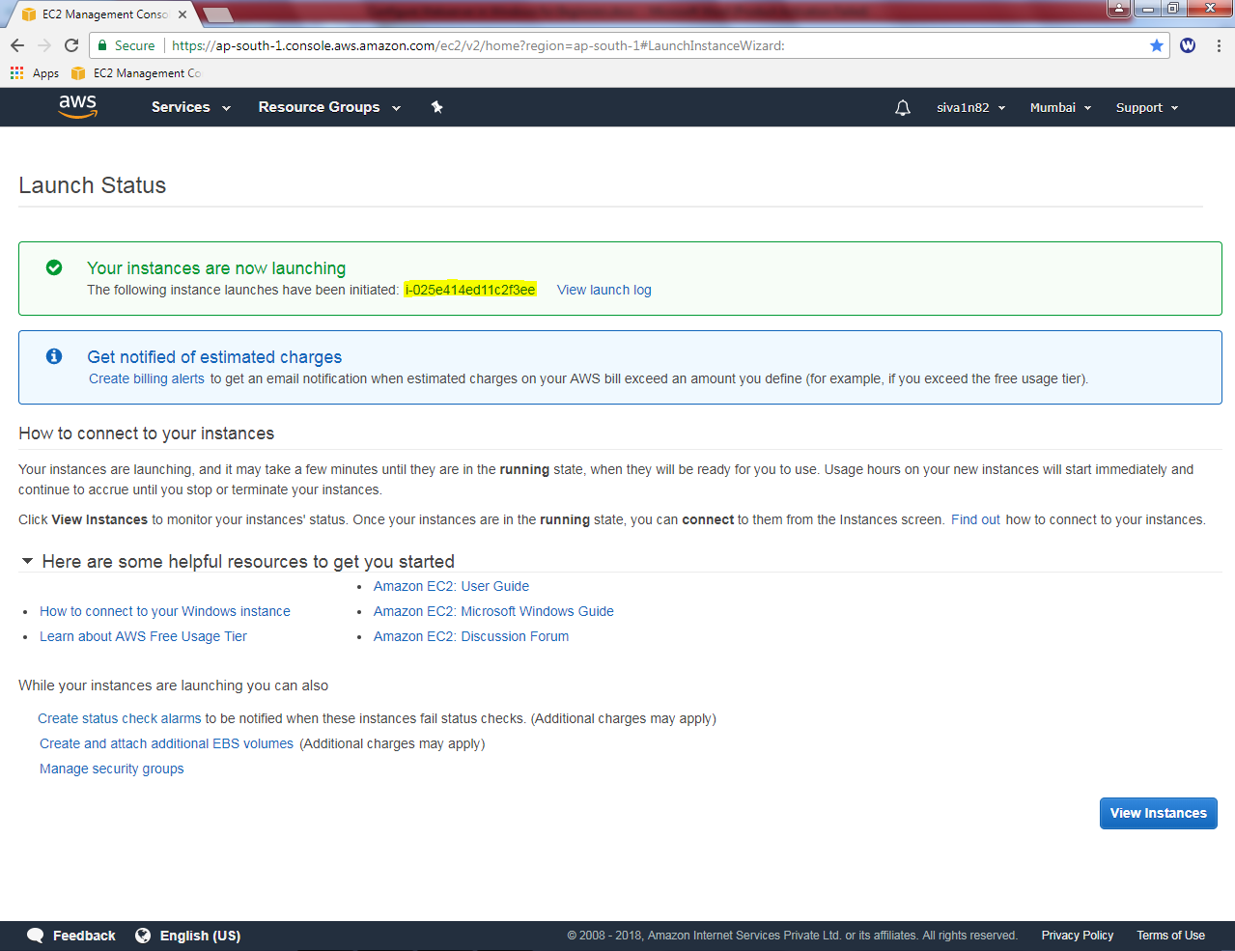

Please wait up to the status checks becomes 2/2 checks.

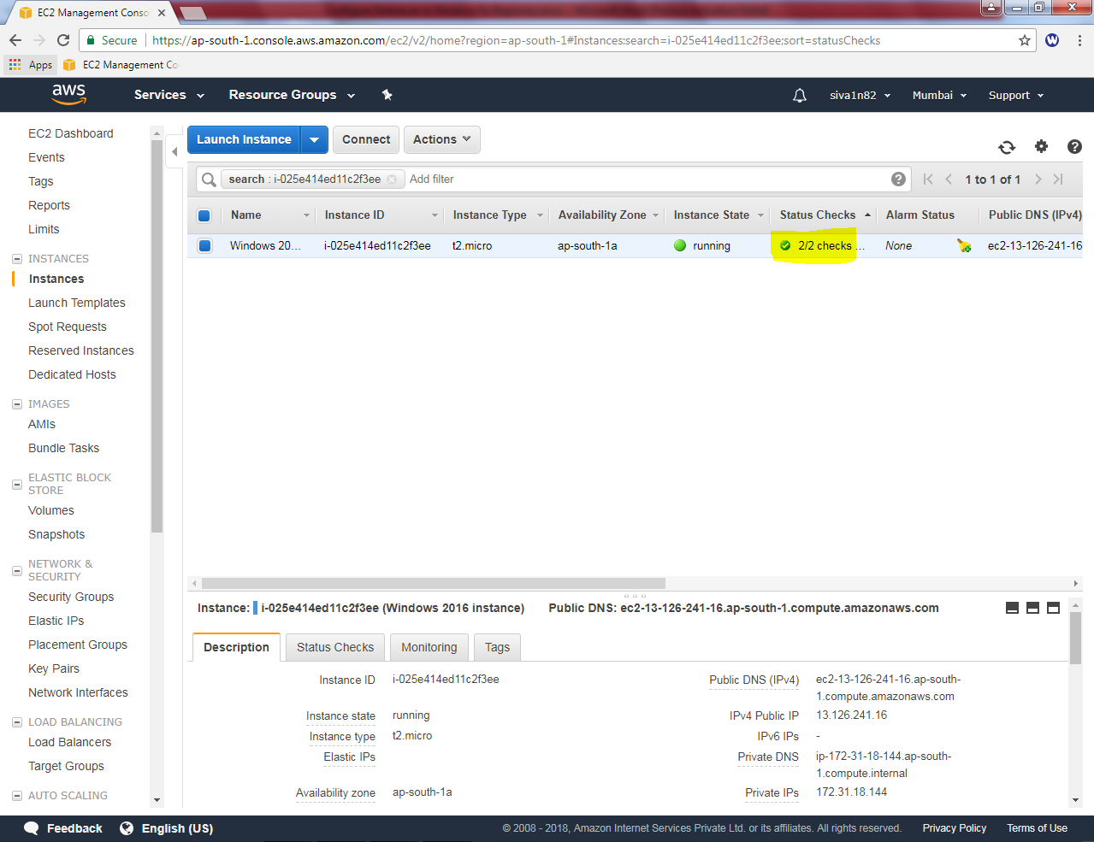

We can able to view the public ip for the windows 2016 server as below.

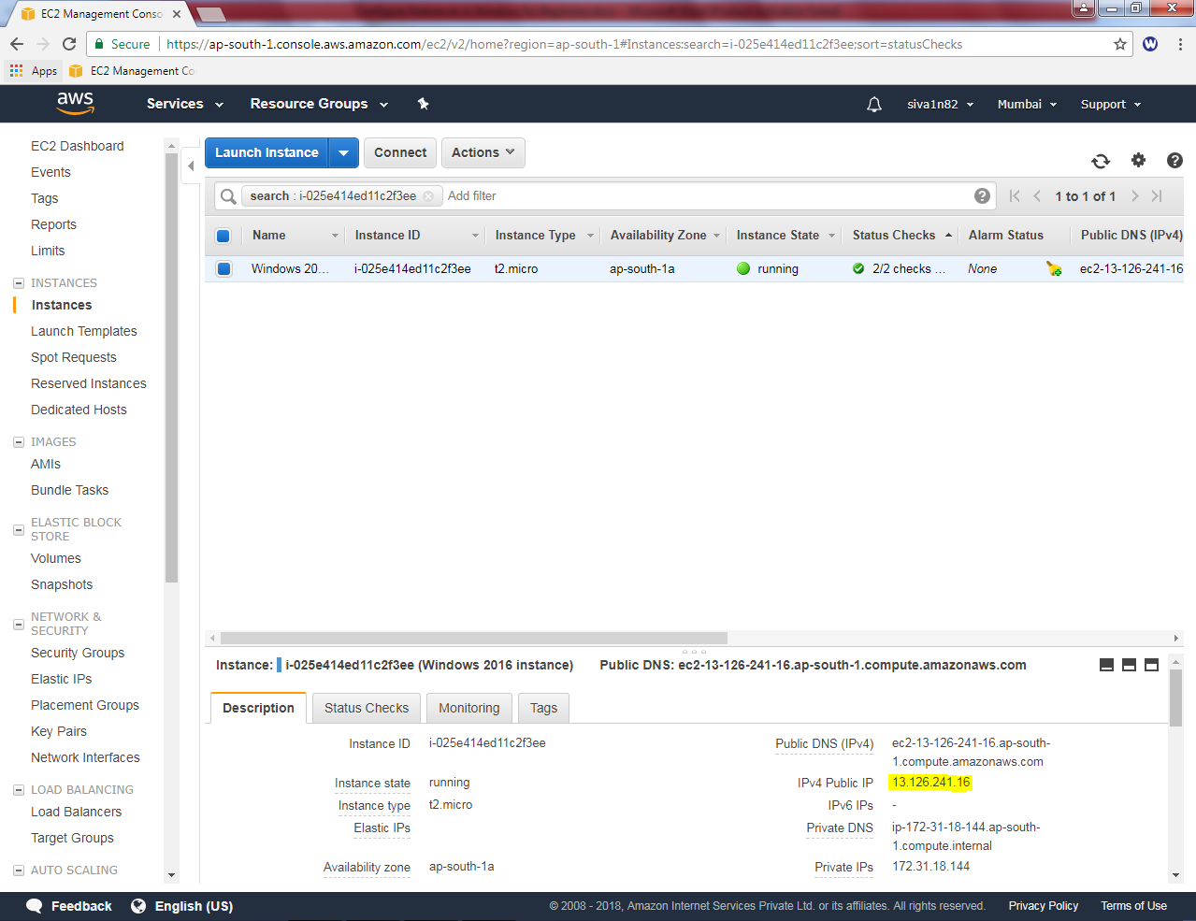

Try to connect the IP, from your local machine by using mstsc in run command.

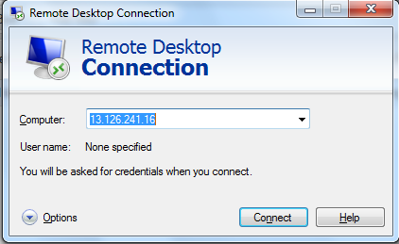

It prompts, password

Username : Administrator

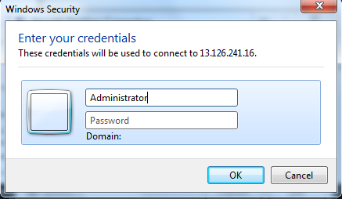

We need to get the password, select the instance and then click “Connect”.

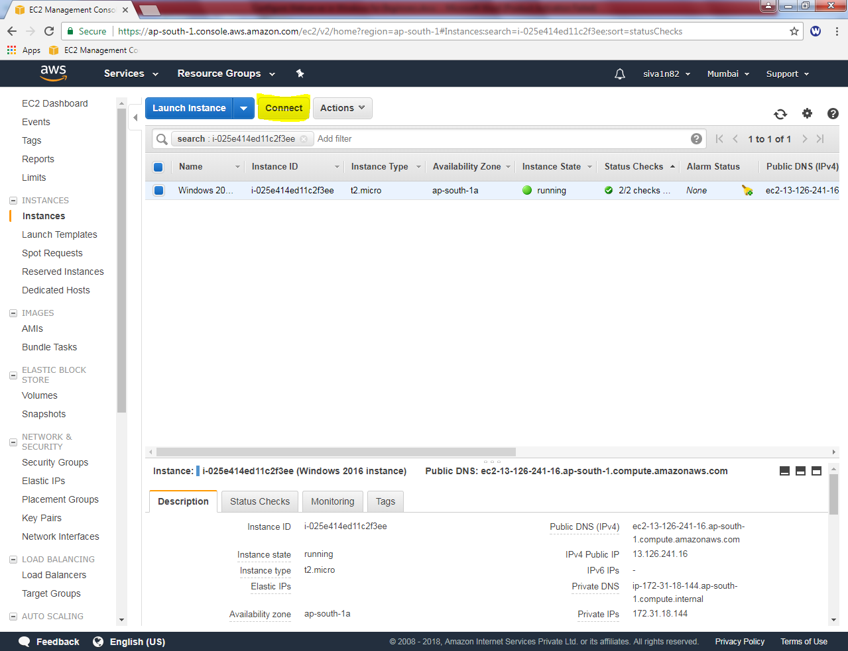

Click “Get Password” button

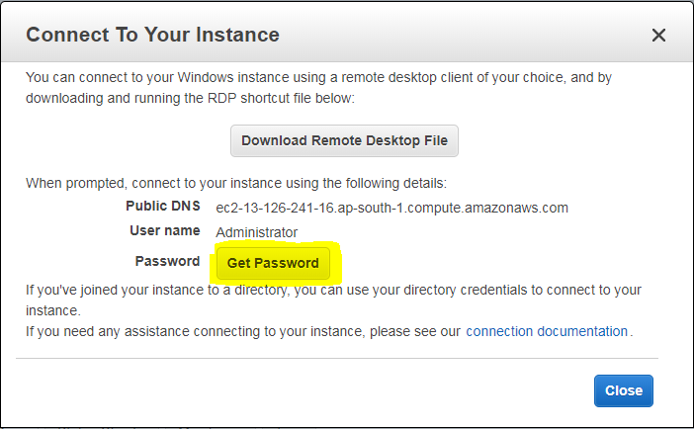

Then click “Choose File” button, and locate the Eveningaws.pem file from the downloaded path.

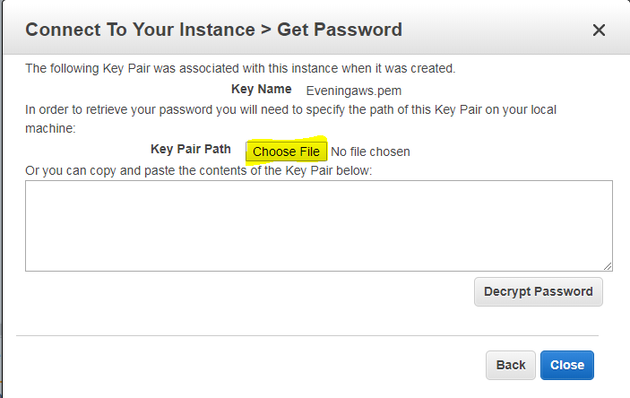

Click “Decrypt password”

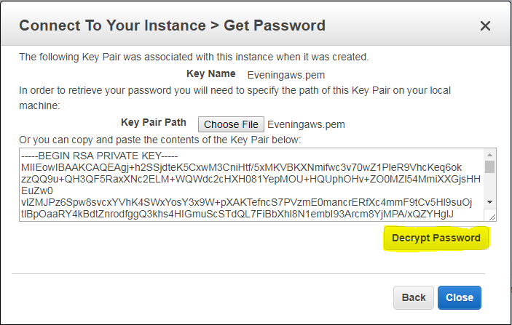

Please find the password for the Windows 2016 server as below.

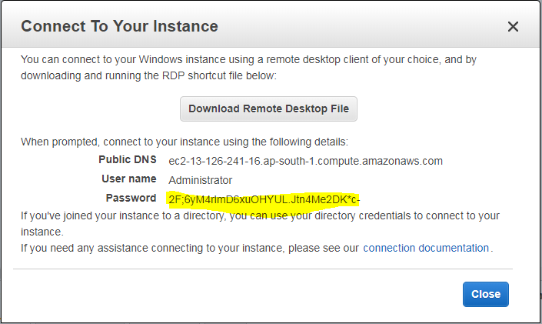

Now trying to connect the server by using above login credentials.

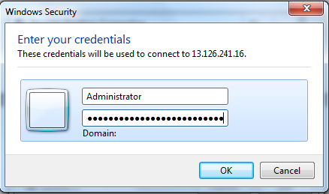

Now we have successfully logged into the server.



In start menu, right click then select command prompt.



In command prompt, type **ipconfig**

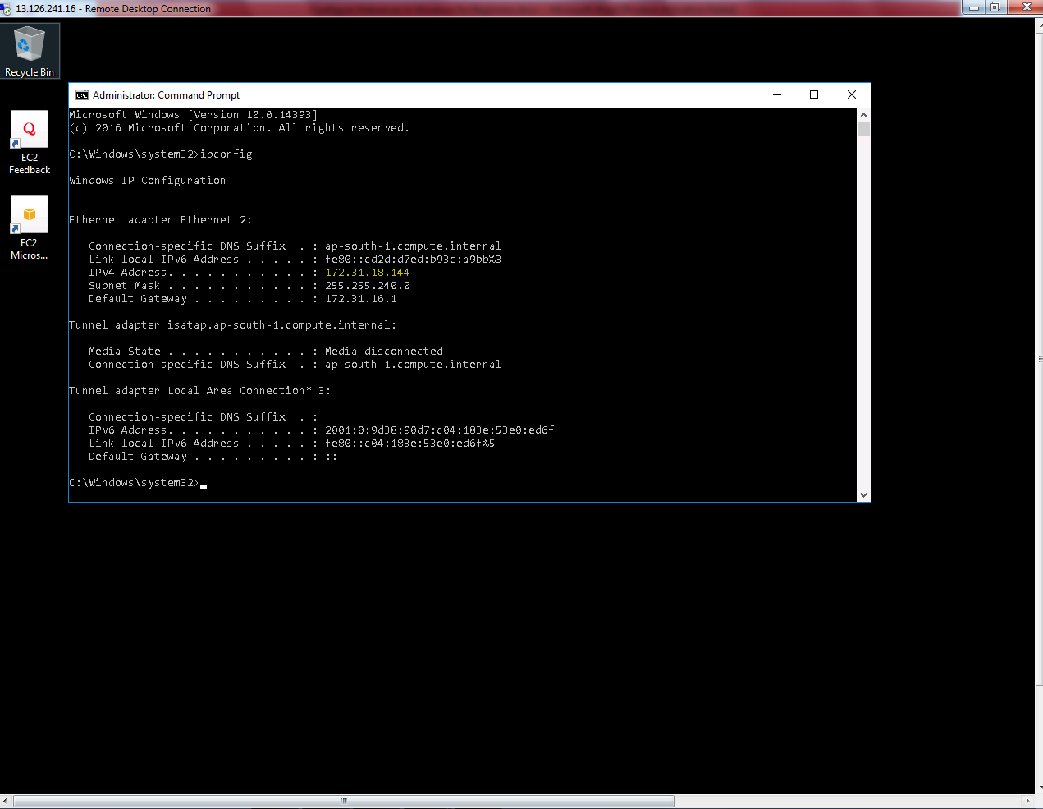

We can able to see the Private IP address of the Windows 2016 server.

.

Click “Server manager”.

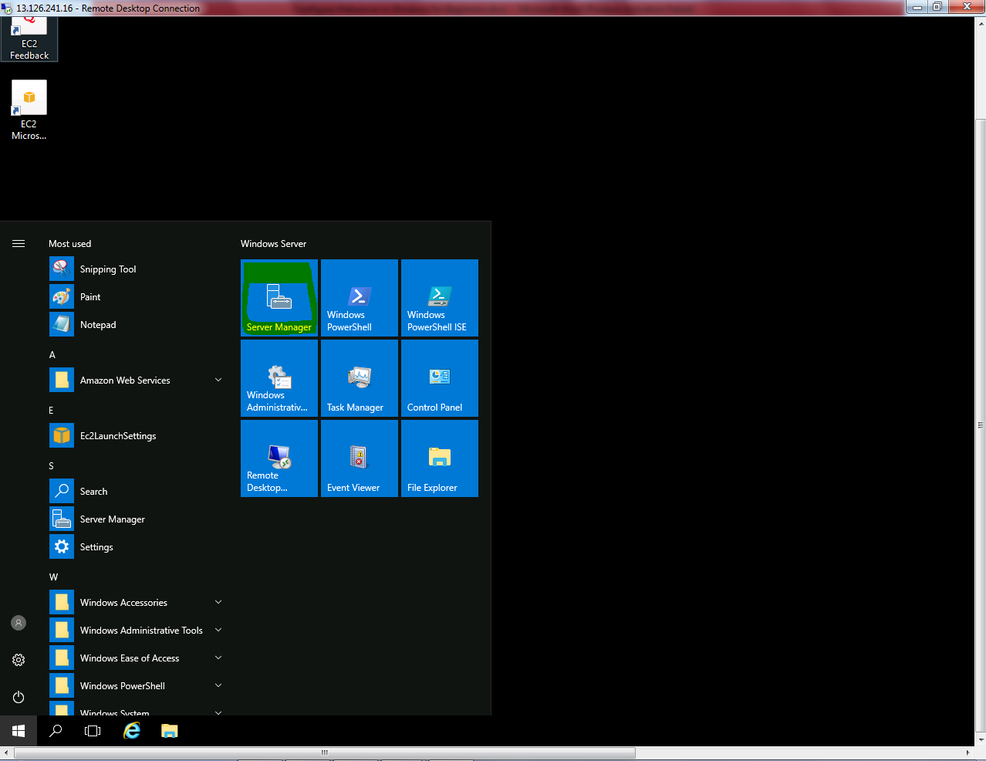

Click “Add Roles and features”

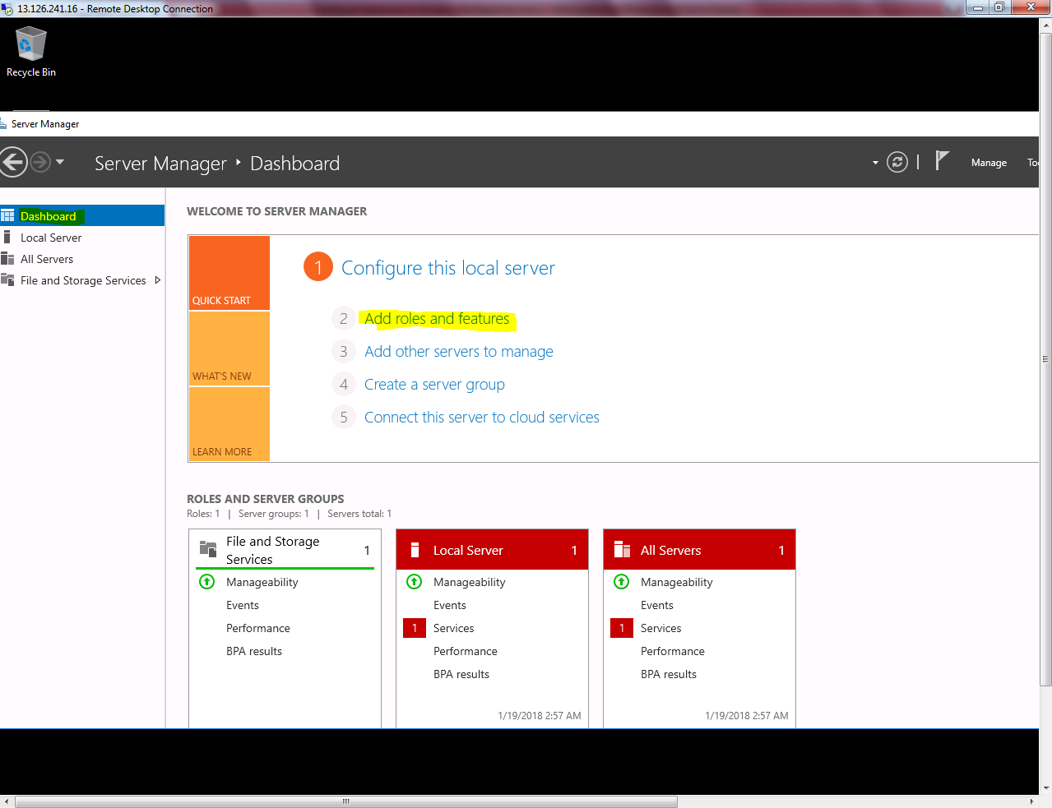

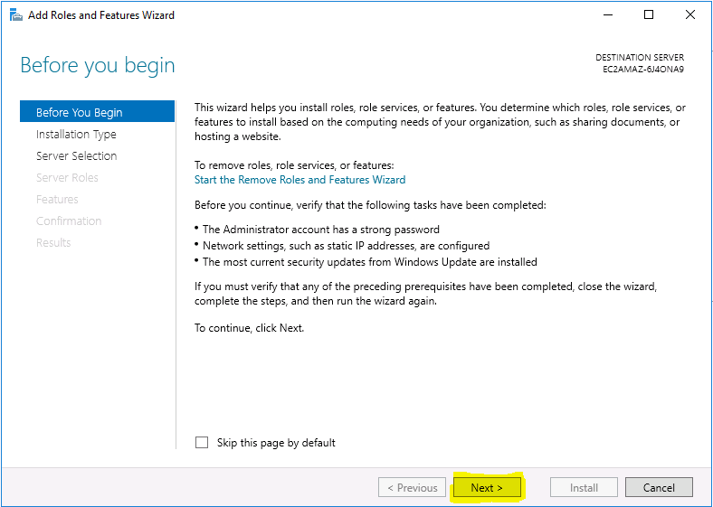

Click “Next”.

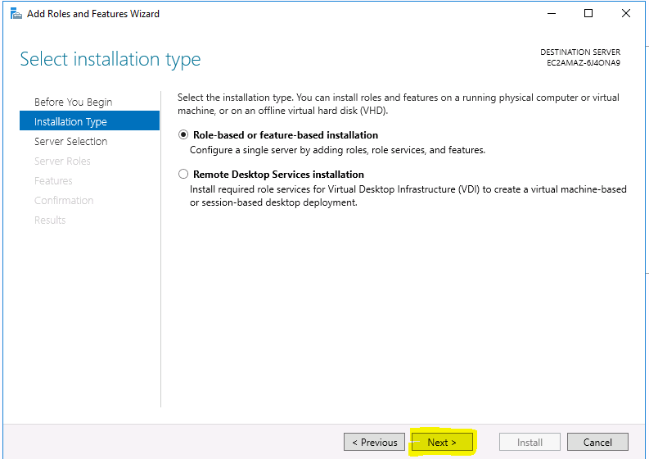

Click “Next”.

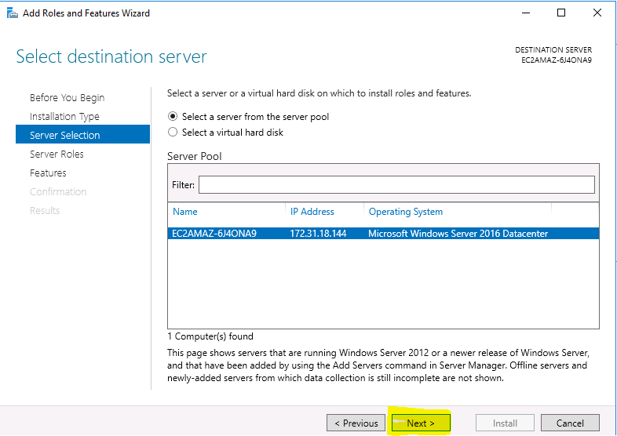

Click “Next”.

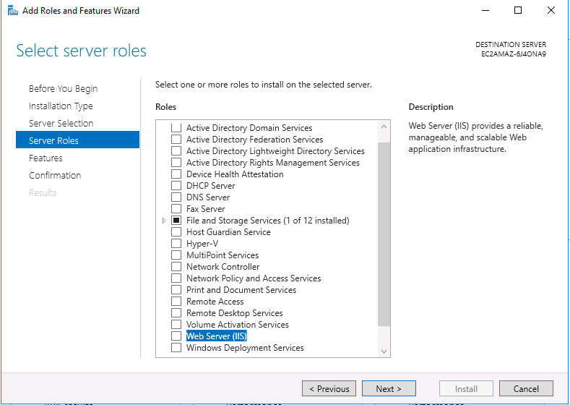

Check “Web server IIS” option button.

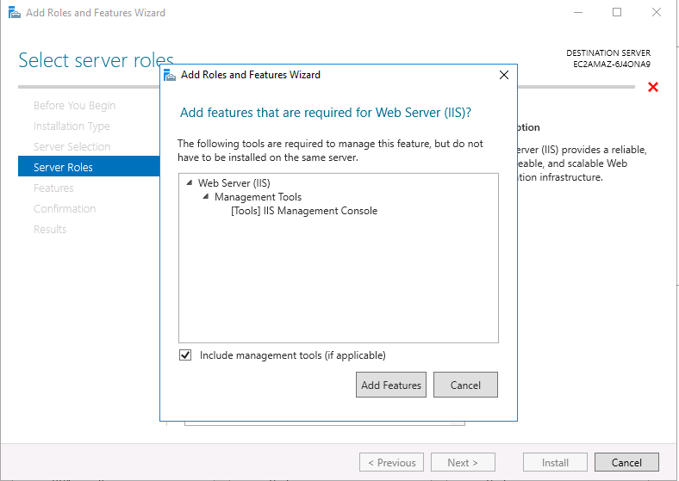

Click “Add features”.

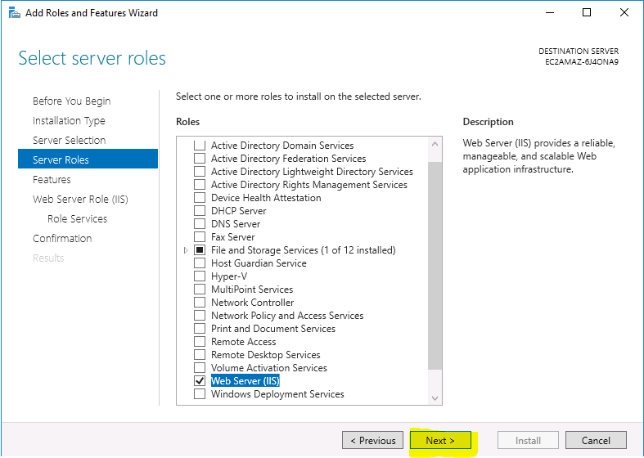

Click “Next”.

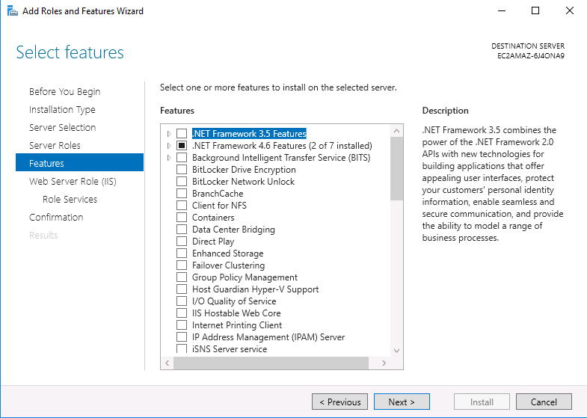

Click “Next”.

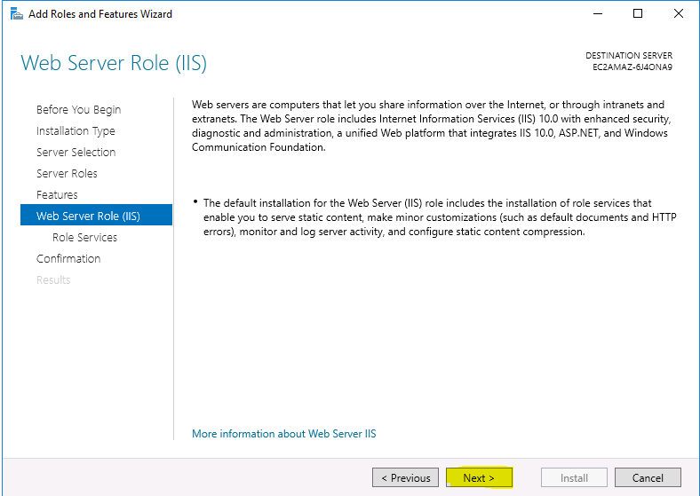

Click “Next”.

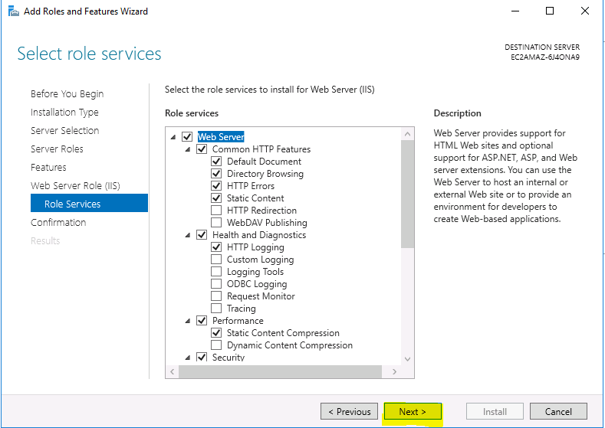

Click “Next”.

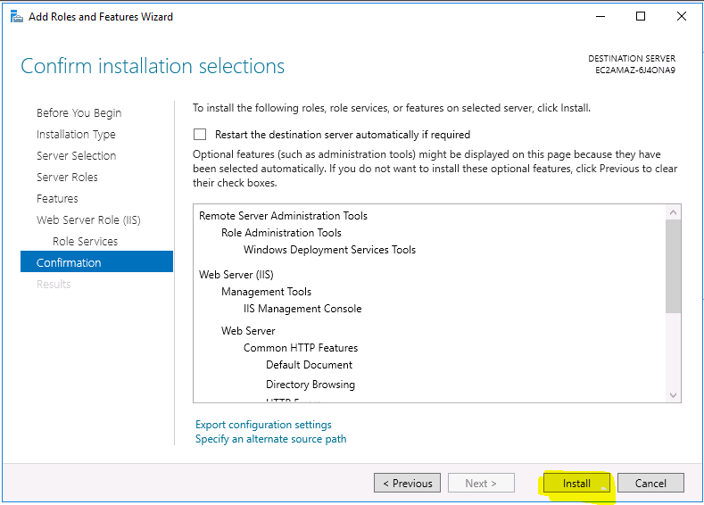

Click “Install”.

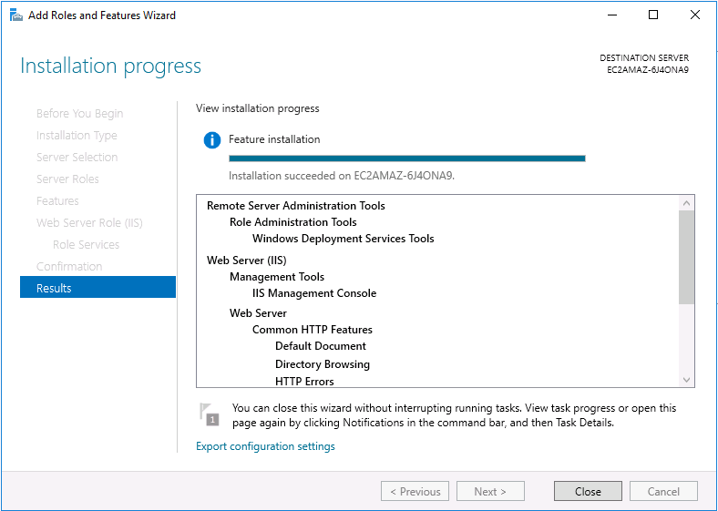

IIS application installed successfully, click close.

In Windows 2016 server, type the private IP address of the server <http://172.31.18.144> in internet explorer to view the web server.

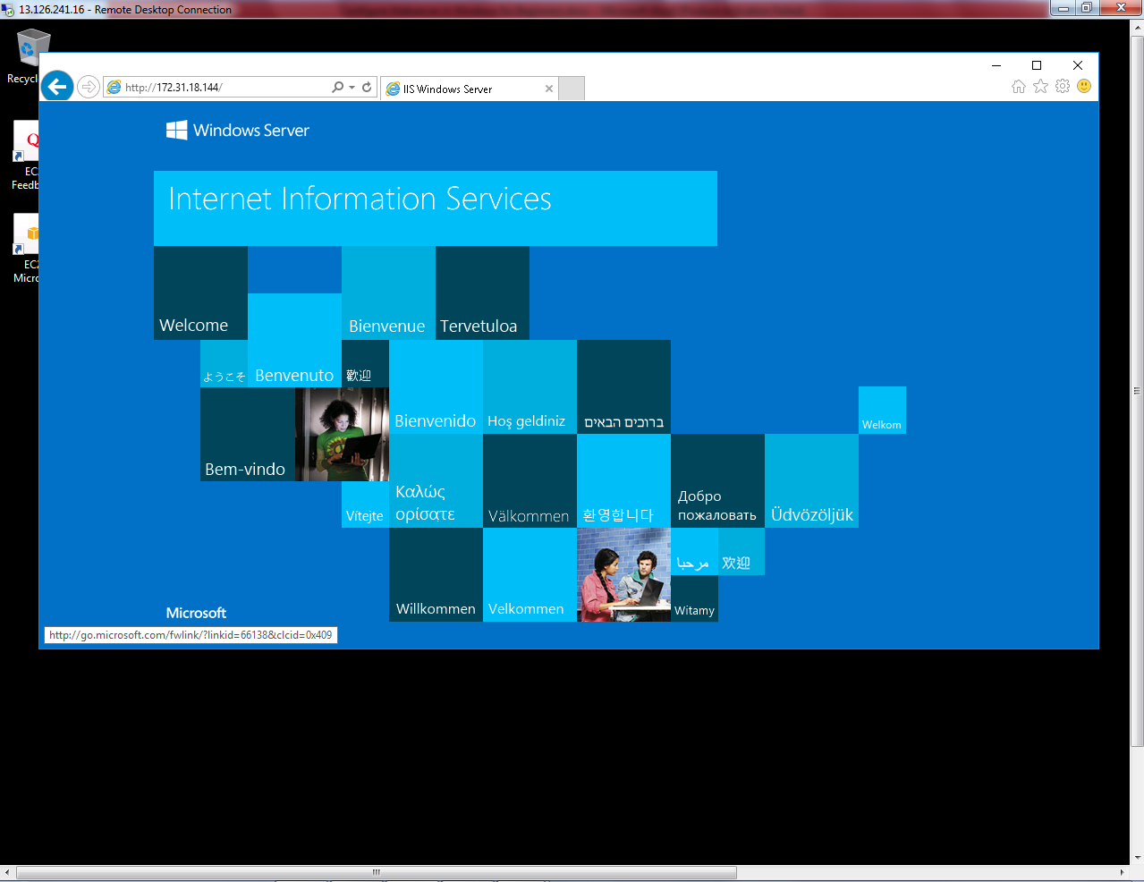

We can able to view the web page by using LAN ip / private IP address of the web server.

Then you can try to connect the public address of the Windows 2016 server in your local machine.

http://13.126.241.16.

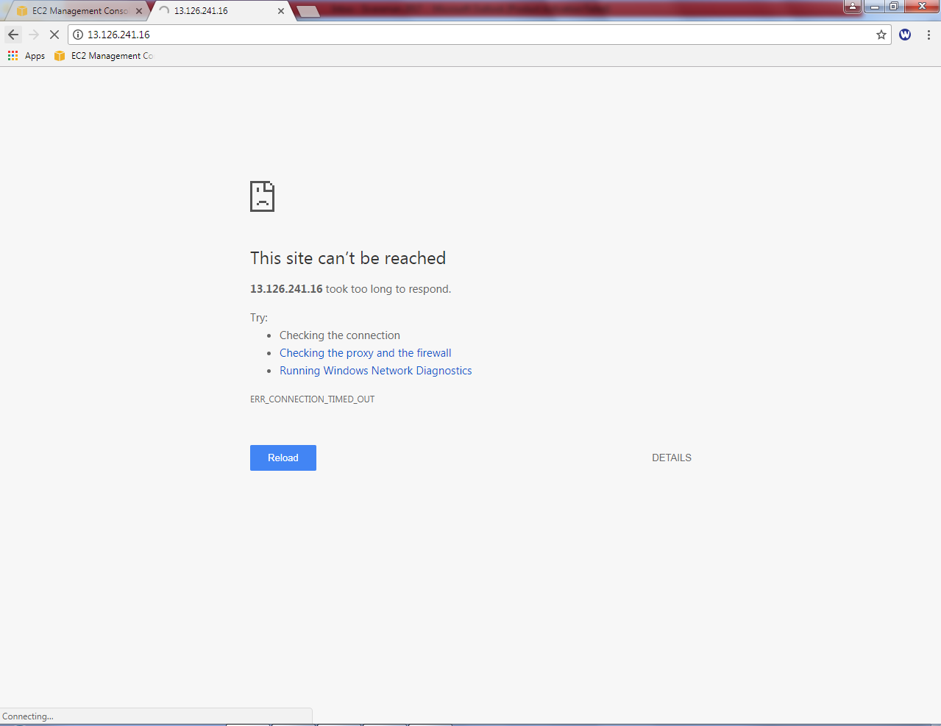

You would not be able to connect, what could be the reason?

In security group, we have permitted only RDP Port (3389). Hence we are unable to connect port 80 from outside of the network. Now we need to allow port 80 (HTTP) in security group “Evening_Sec_Group”.

Goto EC2, click Security Groups and select “Evening_Sec_Group”. Click on Inbound tab, then click “Edit” button.

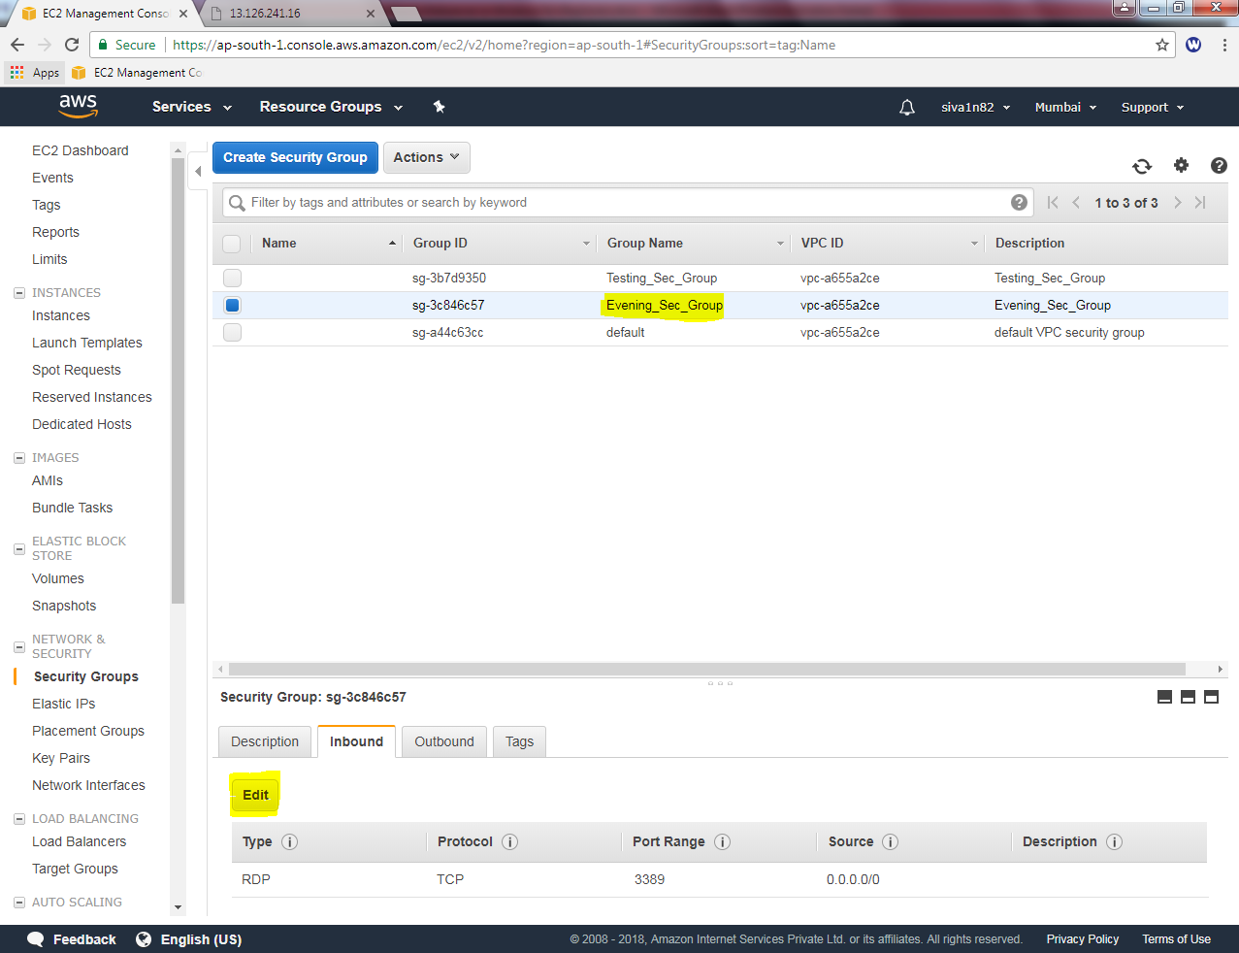

Click “Add Rule”

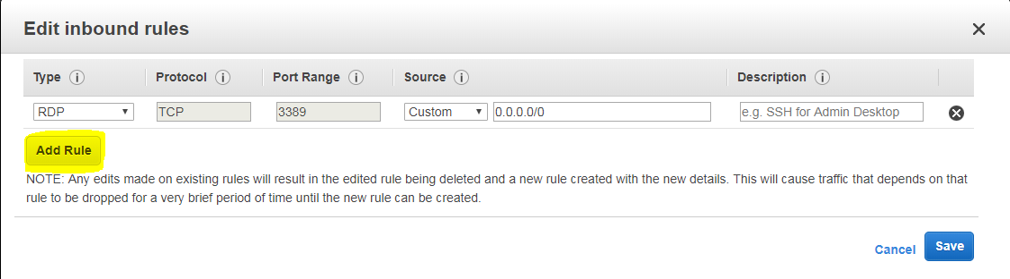

Select Type as “HTTP “ and Source as 0.0.0.0/0 (IPV4) and ::/0 (IPV6).

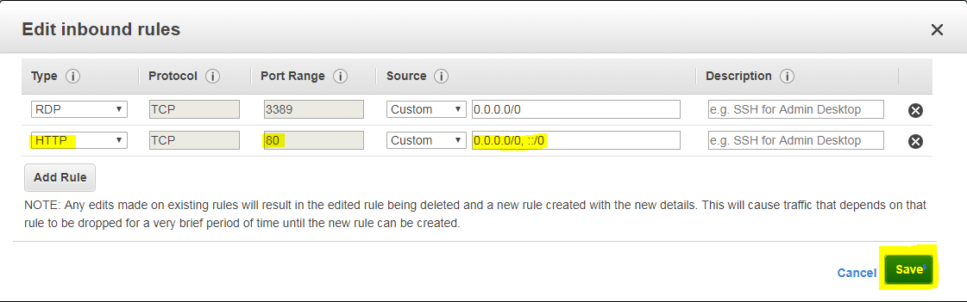

Click “save””.

ry to connect IIS server from local machine, by using public IP address of Windows 2016 server instance.

http://13.126.241.16

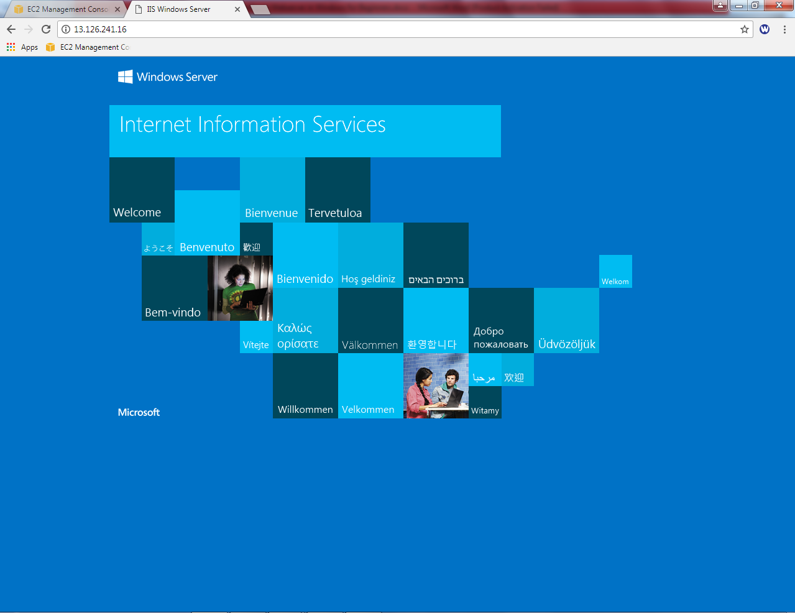

We have got the web server successfully.